Faculty of Engineering, Architecture and Science
Department of Mechanical, Industrial, and Mechatronics Engineering
Program | Electrical Engineering
Course Number | MEC511
Course Title | Thermodynamics and Fluids
Semester/Year | W2026
Instructor | Dr. Jun Cao

Lab/Tutorial Report NO. | Lab Report #2

Report Title | Lab Report #2: The Venturi Flow Meter

Section No. | 09
Submission Date | February 23, 2026
Due Date | February 23, 2026

Name | Student ID | Signature*
Shai Mourad | 501170415
Chaz Dyer | 501304851
Amolika Brahmbhatt | 501295080
Joshua Cardoz | 501025493
Glenn Bangtuan | 501327493

*By signing above you attest that you have contributed to this submission and confirm that all
work you have contributed to this submission is your own work. Any suspicion of copying or
plagiarism in this work will result in an investigation of Academic Misconduct and may result
in a “0” on the work, an “F” in the course, or possibly more severe penalties, as well as a
Disciplinary Notice on your academic record under the Student Code of Academic Conduct,
which can be found online at:
https://www.torontomu.ca/senate/policies/pol60.pdf.

Table of Contents
ii. Summary 2
1. Introduction 3
2. Apparatus 3
3. Procedure 3
4. Results & Calculations 4
4.1 Derivation of Velocity V2 from Bernoulli’s Equation 4
4.2 Raw Data Tables 5
4.3 Calculation of Theoretical Velocity (V2) at the Throat of the Venturi Meter 5
4.4 Calculation of Theoretical Volume Flow Rate (Q) 6
4.5 Calculation of Reynold’s Number (Re) at the Inlet of the Venturi Meter 7
4.6 Calculation of Venturi Discharge Coefficient (Cv) 8
4.7 Calculation of Manometer Actual Velocities 9
4.8 Sample Calculation for the Theoretical Height 12
6. Discussion 15
7. Conclusion 17
8. References 18
9. Appendix 19
9.1. Complete Algebraic Derivation of Velocity V2 from Bernoulli’s Equation 19

ii. Summary
This lab explores incompressible fluid flow through a Venturi flow meter using pressure measurements. Key concepts such as the Bernoulli and continuity equation, are applied to relate pressure differences to volumetric flow rates. During the experiment, flow rates were measured and then compared with theoretical values while accounting for losses (due to the discharge coefficient). The overall results show that the Venturi meter is a valuable tool that gives reliable flow rate measurements, where discrepancies are attributed primarily to viscous effects and non-ideal flow behavior.

1. Introduction
Venturi flow meters are used to measure flow rates in pipes due to their easy use and reliability. It excels in low pressure loss, with its cross-sectional area which causes an increase in fluid velocity and a proportional decrease in static pressure. With measurements of the difference in pressure of the upstream and throat sections, the volumetric flow rate of an incompressible fluid can be determined [2] .

The objective of this experiment is to understand incompressible flow through a Venturi meter and estimate the volumetric flow rate using measurements in pressure. Bernoulli’s and the continuity equation are used to derive the theoretical flow relationship, while experimental data were used to calculate the actual flow rate [1]. The Venturi meter’s performance and reliability are observed based on the comparison of theoretical and experimental results, and examining the impact of energy loss through a discharge coefficient.

2. Apparatus
- Manometer
- Venturi Flow Meter

3. Procedure
- The flow through the Venturi apparatus is adjusted to give the maximum difference between the manometer readings and the upstream location at the Venturi throat.

- All manometer readings were recorded from A - G

- The actual volume flow rate (Q_{a}) of the water was measured. Two measurements were made and the result was averaged.

- The flow rate was adjusted until the difference between the upstream manometer reading and the throat manometer reading was one half of the full flow rate.

- Steps 2 and 3 were repeated again for the half-flow rate.

4. Results & Calculations

4.1 Derivation of Velocity V₂ from Bernoulli’s Equation

The Bernoulli Equation is given as [1] ,

$\frac{P_{1}}{γ}+\frac{V_{1}^{2}}{2g}+z_{1}=\frac{P_{2}}{γ}+\frac{V_{2}^{2}}{2g}+z_{2}$ Eq. 1

The Continuity Equation for Incompressible Flow describes v₁ as,

$V_{1}A_{1}=V_{2}A_{2}$

$V_{1}=\frac{A_{2}}{A_{1}}V_{2}$ Eq. 2

v₁ is replaced by the above equation, and v₂ is isolated to give,

$V_{2}=\sqrt{\frac{2g[\frac{P_{1}-P_{2}}{γ}]+(z_{1}-z_{2})]}{1-{(\frac{A_{2}}{A_{1}})}^{2}}}$ Eq. 3

This equation is used to calculate the velocity (v₂) at the throat of the Venturi meter.

4.2 Raw Data Tables

Table 1. Measured Results for Manometer Readings at Full Flow
Δx (m) | Δt (sec) | Diameter of Container (m) | Height at A  (m)  [$±$0.0005m] | Height at B  (m)  [$±$0.0005m] | Height at C  (m)  [$±$0.0005m] | Height at D  (m)  [$±$0.0005m] | Height at E  (m)  [$±$0.0005m] | Height at F  (m)  [$±$0.0005m] | Height at G  (m)  [$±$0.0005m]
0.3 | 5.75 | 0.0775 | 0.505 | 0.492 | 0.458 | 0.361 | 0.420 | 0.439 | 0.450

Table 2. Measured Results for Manometer Readings at Half Flow
Δx (m) | Δt (sec) | Diameter of Container (m) | Height at A  (m)  [$±$0.0005m] | Height at B  (m)  [$±$0.0005m] | Height at C  (m)  [$±$0.0005m] | Height at D  (m)  [$±$0.0005m] | Height at E  (m)  [$±$0.0005m] | Height at F  (m)  [$±$0.0005m] | Height at G  (m)  [$±$0.0005m]
0.3 | 8.40 | 0.0775 | 0.522 | 0.515 | 0.501 | 0.450 | 0.481 | 0.490 | 0.495

4.3 Calculation of Theoretical Velocity (V₂) at the Throat of the Venturi Meter

For full flow,
$γ=ρ_{water}*g = 997*9.81=9780.57 N/m^{3}$

$P_{1}=γh_{A} =(9780.57*0.505)=4939.19 Pa$

$P_{2}=γh_{D} ==(9780.57*0.361)=3530.79 Pa$

$A_{1}=(0.03175*0.0127) =4.03*10^{-4} m^{3}$

$A_{2}=(0.0127*0.0127)=1.61*10^{-4}m^{3}$

$since the Venturi meter is horizontal, z_{1}-z_{2}= 0$

$V_{2}(full)=\sqrt{\frac{2*9.81[\frac{4939.19-3530.79}{9780.57}]+(0)]}{1-{(\frac{1.61*10^{-4}}{4.03*10^{-4}})}^{2}} }$ = 1.834 m/s

For half flow,${ h}_{A}$ and $h_{D}$ is replaced with the half flow readings at A and D,

$P_{1}=γh_{A} =(9780.57*0.522)=5105.46 Pa$

$P_{2}=γh_{D} ==(9780.57*0.450)=4401.26 Pa$

$V_{2}(half)=\sqrt{\frac{2*9.81[\frac{5105.46-4401.26}{9780.57}]+(0)]}{1-{(\frac{1.61*10^{-4}}{4.03*10^{-4}})}^{2}} }$ = 1.297 m/s

4.4 Calculation of Theoretical Volume Flow Rate (Q)

The Theoretical Volume Flow Rate (Q) is calculated as,

$Q=A_{2}V_{2}$
For full flow,
$Q_{full}=A_{2}V_{2}=(1.61*10^{-4})*(1.834)$

$Q_{full}=2.96*10^{-4} m^{3}/s$

For half flow, $v_{2}$ is replaced by the theoretical velocity calculated at half flow,

$Q_{half}=A_{2}V_{2}=(1.61*10^{-4})*(1.297)$

$Q_{half}=2.09*10^{-4} m^{3}/s$

4.5 Calculation of Reynold’s Number (Re) at the Inlet of the Venturi Meter

In this experiment, Reynold’s Number (Re) is calculated as,

$Re=\frac{ρV_{1}D_{H}}{μ}$ Eq. 4

Where,

$ρ=density of water (kg/m^{3})$
$V_{1}$$=theoretical velocity at inlet (m/s)$
$D_{H}$$=Hydraulic diameter (m)$
$μ =dynamic viscosity of water (Pa*s)$

For full flow,

$ρ=997 kg/m^{3})$

$V_{1}$$=\frac{A_{2}}{A_{1}}V_{2}=\frac{(1.61*10^{-4})}{(4.03*10^{-4})}*1.834 =0.734 m/s$

$P_{wet} =2*(0.03175+0.0127) = 0.089 m$

$D_{H}$$=\frac{ 4A_{1}}{P_{wet}}=\frac{4*(4.03*10^{-4})}{0.089} = 0.018 m$

$μ =0.001 Pa*s)$

$Re (full)=\frac{(997) * (0.734) * (0.018)}{(0.001)}=13274$

For half flow, v₁ was replaced with the velocity at the inlet calculated for the half-flow readings,

$V_{1}$$=\frac{A_{2}}{A_{1}}V_{2}=\frac{(1.61*10^{-4})}{(4.03*10^{-4})}*1.297 =0.519 m/s$

$Re (half)=\frac{(997) * (0.519) * (0.018)}{(0.001)}=9386$

4.6 Calculation of Venturi Discharge Coefficient (C_{v})

$C_{V}=\frac{Q_{A}}{Q_{T}}$ Eq. 5

For full flow,
$Q_{A}=\frac{V}{Δt}$
$V= \frac{πd^{2}}{4}∙Δx$
$V= \frac{π({0.0775)}^{2}}{4}∙(0.3)$
$V=1.415∗10^{-4}{ m}^{3}$

$Q_{A}=\frac{(1.415∗10^{-4}{ m}^{3})}{(5.75s)}$

$Q_{A}=2.461∗10^{-4}{ m}^{3}/s$

$C_{V}=\frac{2.46∗10^{-4}{ m}^{3}/s}{2.96∗10^{-4}{ m}^{3}/s}$

$C_{V}=0.831$

For half flow, the $Δ$t changed

$Q_{A}=\frac{(1.415∗10^{-4}m^{3})}{(8.40s)}$

$Q_{A}=1.68∗10^{-4}{ m}^{3}/s$

$C_{V}=\frac{1.68∗10^{-4}m^{3}/s/s}{2.09∗10^{-4}m^{3}/s}$

$C_{V}=0.806$

Table 3. Calculated Values (Part 2-4)
Flow Type | Theoretical Velocity (V₂) at the Throat of the Venturi Meter [m/s] | Theoretical Volume Flow Rate (Q) [m³/s] | Reynold’s Number (Re) at the Inlet of the Venturi Meter | Venturi Discharge Coefficient (C_{v}) []
Full Flow | 1.834 | 2.96*10⁻⁴ | 13274 | 0.831
Half Flow | 1.297 | 2.09*10⁻⁴ | 9386 | 0.806

4.7 Calculation of Manometer Actual Velocities

For full flow,
$V_{}=\frac{Q_{A}}{A_{}}$ Eq. 6

$V_{A}=\frac{2.461∗10^{-4}}{(4.032∗10^{-4})}$

$V_{A}=0.610 m/s$
$V_{B}=\frac{2.461∗10^{-4}}{(3.226∗10^{-4})}$

$V_{B}=0.763 m/s$

$V_{C}=\frac{2.461∗10^{-4}}{(2.419∗10^{-4})}$

$V_{C}=1.017 m/s$

$V_{D}=\frac{2.461∗10^{-4}}{(1613∗10^{-4})}$

$V_{D}=1.525 m/s$

$V_{E}=\frac{2.461∗10^{-4}}{(2.419∗10^{-4})}$

$V_{E}=1.017 m/s$

$V_{F}=\frac{2.461∗10^{-4}}{(3.226∗10^{-4})}$

$V_{F}=0.763 m/s$

$V_{G}=\frac{2.461∗10^{-4}}{(4.032∗10^{-4})}$

$V_{G}=0.610 m/s$

Table 4. Calculated Actual Manometer Velocities for Full Flow in Meters Per Second
Tap | Manometer Actual Velocities (m/s)
A | 0.610
B | 0.763
C | 1.017
D | 1.525
E | 1.017
F | 0.763
G | 0.610

For half flow,

$V_{}=\frac{Q_{A}}{A_{}}$

$V_{A}=\frac{1.68∗10^{-4}}{(4.032∗10^{-4})}$

$V_{A}=0.417 m/s$
$V_{B}=\frac{1.68∗10^{-4}}{(3.226∗10^{-4})}$

$V_{B}=0.521 m/s$

$V_{C}=\frac{1.68∗10^{-4}}{(2.419∗10^{-4})}$

$V_{C}=0.694 m/s$

$V_{D}=\frac{1.68∗10^{-4}}{(1.613∗10^{-4})}$

$V_{D}=1.042 m/s$

$V_{E}=\frac{1.68∗10^{-4}}{(2.419∗10^{-4})}$

$V_{E}=0.694 m/s$

$V_{F}=\frac{1.68∗10^{-4}}{(3.226∗10^{-4})}$

$V_{F}=0.521 m/s$

$V_{G}=\frac{1.68∗10^{-4}}{(4.032∗10^{-4})}$

$V_{G}=0.417 m/s$

Table 5. Calculated Actual Manometer Velocities for Half Flow in Meters Per Second
Tap | Manometer Actual Velocities (m/s)
A | 0.417
B | 0.521
C | 0.694
D | 1.042
E | 0.694
F | 0.521
G | 0.417

4.8 Sample Calculation for the Theoretical Height

For full flow,
$H_{i}=H_{A}-\frac{{V_{i}}^{2}-{V_{A}}^{2}}{2g}$ Eq. 7

$H_{D}=H_{A}-\frac{{V_{D}}^{2}-{V_{A}}^{2}}{2g}$

$H_{D}=(0.505)-\frac{(1.525)^{2}-(0.610)^{2}}{2(9.81)}$

$H_{D}=0.405m$

Table 6. Calculated Theoretical Heights for Full Flow in Meters
Tap | Theoretical Height (m)
A | 0.505
B | 0.494
C | 0.471
D | 0.405
E | 0.471
F | 0.494
G | 0.505

Figure 1. Graph of Calculated Theoretical Heights for Full Flow in Meters
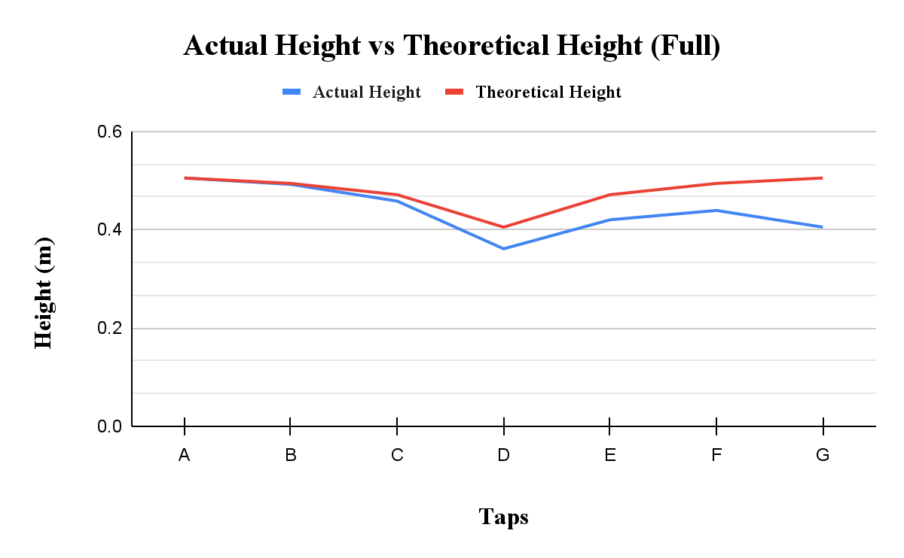
For half flow,
$H_{i}=H_{A}-\frac{{V_{i}}^{2}-{V_{A}}^{2}}{2g}$
$H_{D}=H_{A}-\frac{{V_{D}}^{2}-{V_{A}}^{2}}{2g}$
$H_{D}=(0.522)-\frac{(1.042)^{2}-(0.417)^{2}}{2(9.81)}$
$H_{D}=0.476m$
Table 7. Calculated Theoretical Heights for Half Flow in Meters
Tap | Theoretical Height (m)
A | 0.522
B | 0.517
C | 0.506
D | 0.476
E | 0.506
F | 0.517
G | 0.522

Figure 2. Graph of Calculated Theoretical Heights for Full Flow in Meters
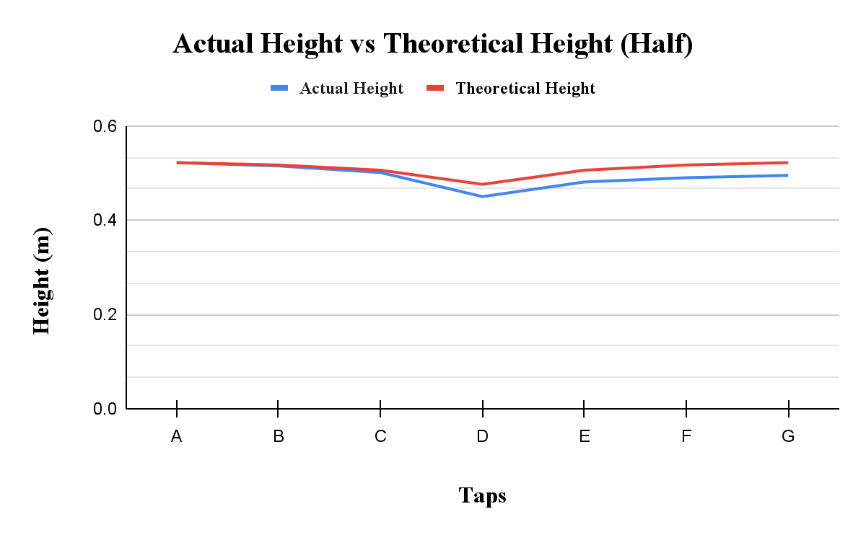

Figure 3: Approximate Range of Discharge Coefficients (Cv) for Venturi Flow Meters [1]
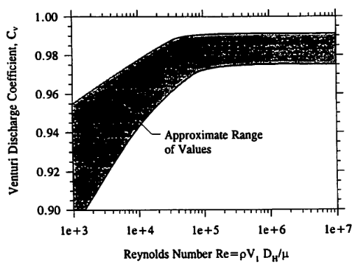

6. Discussion
The theoretical velocity at the throat of the Venturi meter was determined using Bernoulli’s equation and the continuity equation, which assume steady, incompressible, and inviscid flow with negligible head losses. For a horizontal Venturi meter, the elevation terms cancel out, simplifying Bernoulli’s equation to relate only pressure and velocity. However, Bernoulli’s equation assumes an ideal fluid with zero viscosity and non friction effects. In reality, fluids possess viscosity, which causes energy losses due to friction between the fluid and the pipe walls, as well as internal friction within the fluid itself. Real-world factors such as turbulent flow, fluid resistance, and energy dissipation introduce head losses that are not accounted for in the ideal equation. The calculated Reynolds numbers for full and half flow indicate turbulent flow conditions, which further increase frictional losses. As a result of these energy losses, the actual fluid velocity is lower than the theoretical velocity predicted by Bernoulli’s equation.
The discharge coefficients calculated were 0.831 for full flow and 0.806 for half flow, which are lower than the values shown in Figure 3. Based on the calculated Reynolds numbers, the flow in both cases was in the turbulent region. According to the figure, the discharge coefficient in this region is expected to remain relatively constant and close to 1. Since the Reynolds numbers fall within that range, the discharge coefficient should have followed the same trend. However, the experimental values were noticeably lower, indicating that additional losses were present in the system. Although the theoretical analysis assumes ideal conditions, the actual apparatus introduces physical factors that affect the results. The inner surface of the Venturi meter is not perfectly smooth, which increases friction between the fluid and the walls and leads to greater energy dissipation. In addition, losses in the diffuser section may have reduced pressure recovery as the fluid expanded after the throat. Increased turbulence in this region would further contribute to head loss. These effects reduce the measured actual flow rate, resulting in a discharge coefficient that is lower than the value suggested by the figure.
Based on the manometer readings, the pressure head decreased from the inlet to the throat, where the minimum value was recorded. This behaviour is consistent with Bernoulli’s principle, since a decrease in cross sectional area results in an increase in velocity and a corresponding decrease in pressure. After the throat, the pressure head increased again in the diverging section, indicating partial pressure recovery as the velocity decreased. However, the pressure at the outlet did not return to the same value as at the inlet, as shown by the lower final manometer reading. This difference represents head loss within the system. Although the converging section is shaped to reduce energy losses, the diverging section is more likely to experience increased turbulence and incomplete pressure recovery as the fluid expands. Because of this, the greatest head losses in the Venturi meter occurred in the diffuser section downstream of the throat, where the expanding flow caused additional energy to be lost.

7. Conclusion
The objective of this experiment was to investigate the water flow through a Venturi flow meter and to determine the theoretical and actual volume flow rates using Bernoulli’s equation and pressure measurements. The discharge coefficient of the Venturi meter was also evaluated and compared with expected values from literature.
The theoretical flow rate was obtained using Bernoulli’s equation, while the actual flow rate was measured experimentally. In both test conditions, the actual flow rate was lower than the theoretical value. This difference occurred because Bernoulli’s equation assumes ideal flow and does not account for friction and other energy losses in the Venturi meter.
The calculated Reynolds numbers, 13274 for full flow and 9386 for half flow, showed that the flow was turbulent for both cases. The discharge coefficients of 0.831 and 0.806 for full flow and half flow respectively were slightly less than 1, which is expected for real flow due to head losses in the system. The results also showed that pressure was the lowest at the throat and that some energy was lost downstream of the throat. Overall, the experiment confirmed the expected relationship between pressure and velocity in a Venturi flow meter while demonstrating the effects of real fluid behaviour.

8. References

[1] R. S. Budny, MEC511 Laboratory Manual: The Venturi Flow Meter (Lab 2), Dept. of Mechanical and Industrial Engineering, Faculty of Engineering, Architecture and Science, Ryerson University, Jan. 2016.
[2] R. D. Blevins, Applied Fluid Dynamics Handbook, New York, NY, USA: Van Nostrand Reinhold, 1984.

9. Appendix

9.1. Complete Algebraic Derivation of Velocity V₂ from Bernoulli’s Equation

Bernoulli’s equation is given,

$\frac{P_{1}}{γ}+\frac{V_{1}^{2}}{2g}+z_{1}=\frac{P_{2}}{γ}+\frac{V_{2}^{2}}{2g}+z_{2}$

Isolating for v₁ and v₂ obtains,

$\frac{P_{1}}{γ}-\frac{P_{2}}{γ}+\frac{V_{1}^{2}}{2g}-\frac{V_{2}^{2}}{2g}+z_{1}-z_{2}=0$

$\frac{V_{2}^{2} - V_{1}^{2}}{2g}=\frac{P_{1} -{ P}_{2}}{γ}+(z_{1}-z_{2})$

Factoring 2g and multiplying it by both sides,

$\frac{1}{2g}[V_{2}^{2} - V_{1}^{2}]=\frac{P_{1} -{ P}_{2}}{γ}+(z_{1}-z_{2})$

$V_{2}^{2} - V_{1}^{2}=2g[\frac{P_{1} -{ P}_{2}}{γ}+(z_{1}-z_{2})$]

The Continuity Equation for Incompressible Flow describes v₁ as,

$V_{1}A_{1}=V_{2}A_{2}$

Isolating for v₁,
$V_{1}=\frac{A_{2}}{A_{1}}V_{2}$

Substituting v₁ into the equation,

$V_{2}^{2} - (\frac{A_{2}}{A_{1}}V_{2})^{2}=2g[\frac{P_{1} -{ P}_{2}}{γ}+(z_{1}-z_{2})$]

$V_{2}^{2} [1-(\frac{A_{2}}{A_{1}})^{2}]=2g[\frac{P_{1} -{ P}_{2}}{γ}+(z_{1}-z_{2})$]

Isolating for v₂,
$V_{2}^{2} = \frac{2g[\frac{P_{1} -{ P}_{2}}{γ}+(z_{1}-z_{2})]}{ [1-(\frac{A_{2}}{A_{1}})^{2}]}$

$V_{2}=\sqrt{\frac{2g[\frac{P_{1}-P_{2}}{γ}]+(z_{1}-z_{2})]}{1-{(\frac{A_{2}}{A_{1}})}^{2}}}$

